| **Test Name** | Status message sent on input pin change |
| --- | --- |
| **Use Case Tested:** |  |
| **Test Description:** | This test verifies the firmware sends a status message when one of the pump status input pins changes state. |
| **Pre-conditions** | * Pump controller is running. * Tester connected to the pump controller with the serial monitor. * The pump is idle (the build-in LED is off). |
| **Post-conditions** | Same as pre-conditions. |
| **Notes:** |  |

|  | **TEST STEP** | **EXPECTED TEST RESULTS** |
| --- | --- | --- |
|  | Ground the bore low level pin (pin 0). | A status message is sent with boreLowLevel: 1, all other flags 0.  A bore low level alarm is raised in the dashboard.  The bore low level LED lights up on the dashboard. |
|  | Unground the bore low level pin (pin 0). | A status message is sent with all flags set to 0.  The bore low level alarm is cleared in the dashboard.  The bore low level LED goes out on the dashboard. |
|  | Ground the soft start fail pin (pin 1). | A status message is sent with softStartFail: 1, all other flags 0.  A soft start fail alarm is raised in the dashboard.  The soft start fail LED lights up on the dashboard. |
|  | Unground the soft start fail pin (pin 1). | A status message is sent with all flags set to 0.  The soft start fail alarm is cleared in the dashboard.  The soft start fail LED goes out on the dashboard. |
|  | Ground the no flow pin (pin 10). | A status message is sent with noFlow: 1, all other flags 0.  A no flow alarm is raised in the dashboard.  The no flow LED lights up on the dashboard. |
|  | Unground the no flow pin (pin 10). | A status message is sent with all flags set to 0.  The no flow alarm is cleared in the dashboard.  The no flow LED goes out on the dashboard. |
|  | Ground the pump overload pin (pin 11). | A status message is sent with pumpOverload: 1, all other flags 0.  A pump overload alarm is raised in the dashboard.  The pump overload LED lights up on the dashboard. |
|  | Unground the pump overload pin (pin 11). | A status message is sent with all flags set to 0.  The pump overload alarm is cleared in the dashboard.  The pump overload LED goes out on the dashboard. |
|  | Ground the high pressure pin (pin 12). | A status message is sent with highPressure: 1, all other flags 0.  A high pressure alarm is raised in the dashboard.  The high pressure LED lights up on the dashboard. |
|  | Unground the high pressure pin (pin 12). | A status message is sent with all flags set to 0.  The high pressure alarm is cleared in the dashboard.  The high pressure LED goes out on the dashboard. |

|  |  |  |  |  |  |
| --- | --- | --- | --- | --- | --- |
| **Test Data Table** | | | | | |
|  | **1** | **2** | **3** | **4** | **5** |
| [Data field 1] | [data set 1 input value for field 1] |  |  |  |  |
| [Data field 2] | [data set 1 input value for field 2] |  |  |  |  |
| [Data field 3] | [data set 1 input value for field 3] |  |  |  |  |

**Results**

10/09/2020

Passed.

Steps 1 & 2 bore low level

14:10:02.498 -> Sending status due to state change.

14:10:02.498 -> LoRaWAN will encode and send this message: {'pumpRunning':0,'boreLowLevel':1,'softStartFail':0,'pumpOverload':0,'controllerRestart':0,'highPressure':0,'noFlow':0}

14:10:02.498 -> Sending status byte: 02

14:10:04.863 -> EV_TXCOMPLETE (includes waiting for RX windows)

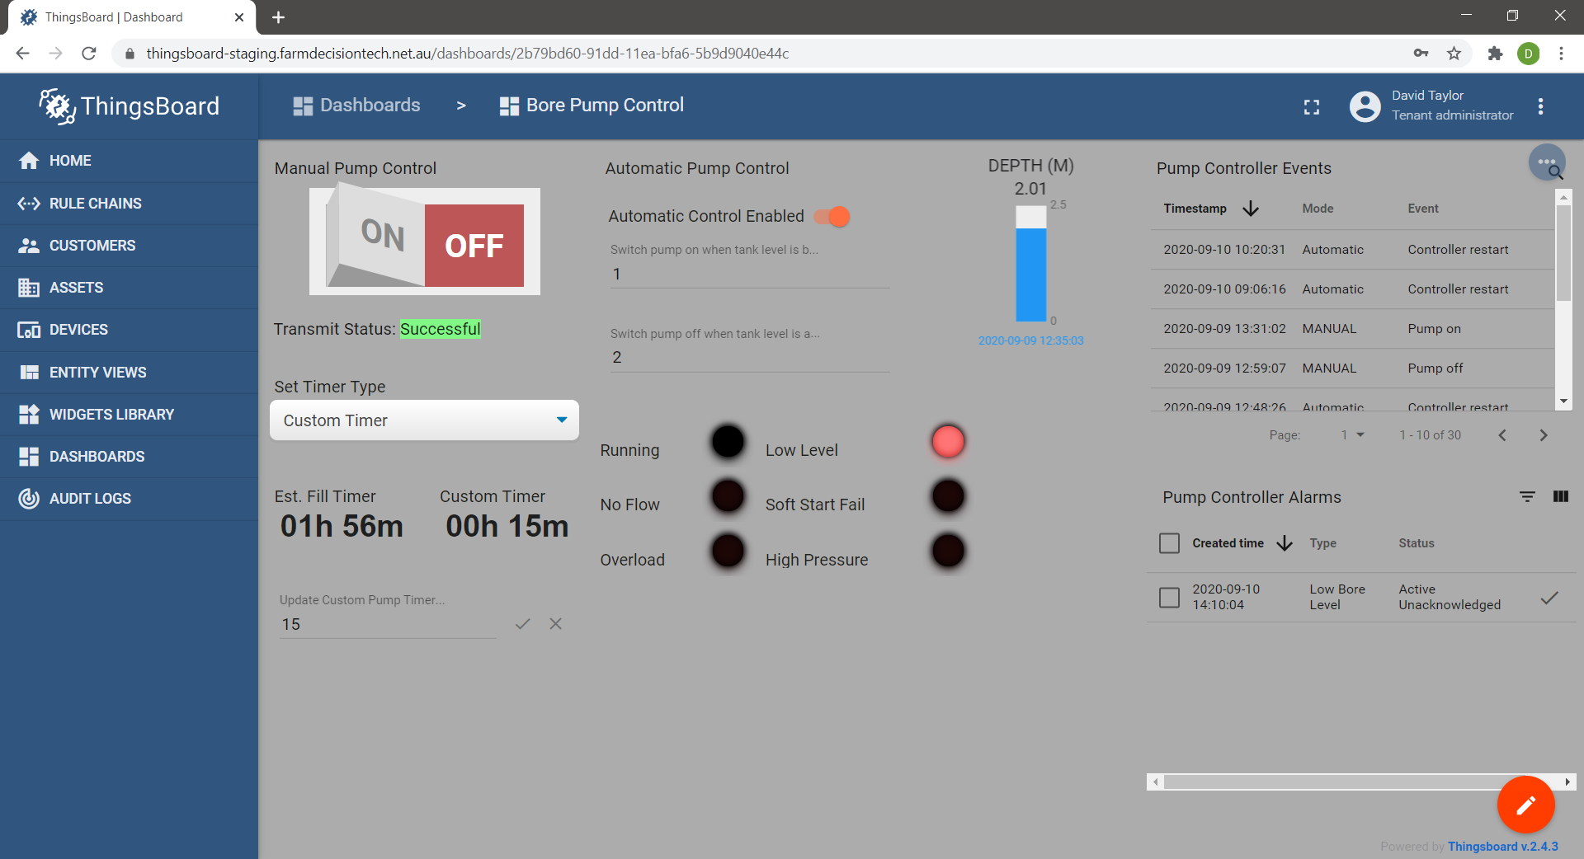

14:11:15.232 -> Sending status due to state change.

14:11:15.232 -> LoRaWAN will encode and send this message: {'pumpRunning':0,'boreLowLevel':0,'softStartFail':0,'pumpOverload':0,'controllerRestart':0,'highPressure':0,'noFlow':0}

14:11:15.232 -> Sending status byte: 00

14:11:17.595 -> EV_TXCOMPLETE (includes waiting for RX windows)

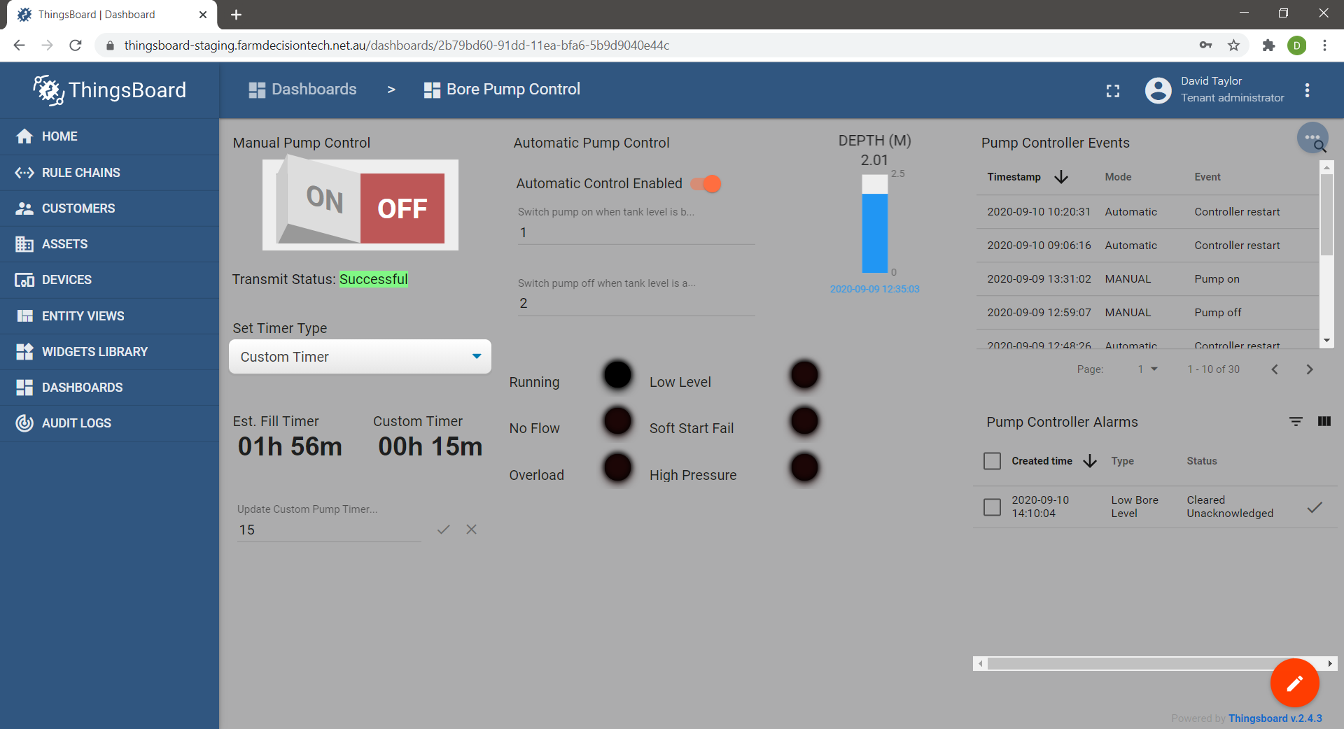

Steps 3 & 4 soft start fail

14:13:01.784 -> Sending status due to state change.

14:13:01.784 -> LoRaWAN will encode and send this message: {'pumpRunning':0,'boreLowLevel':0,'softStartFail':1,'pumpOverload':0,'controllerRestart':0,'highPressure':0,'noFlow':0}

14:13:01.784 -> Sending status byte: 04

14:13:04.163 -> EV_TXCOMPLETE (includes waiting for RX windows)

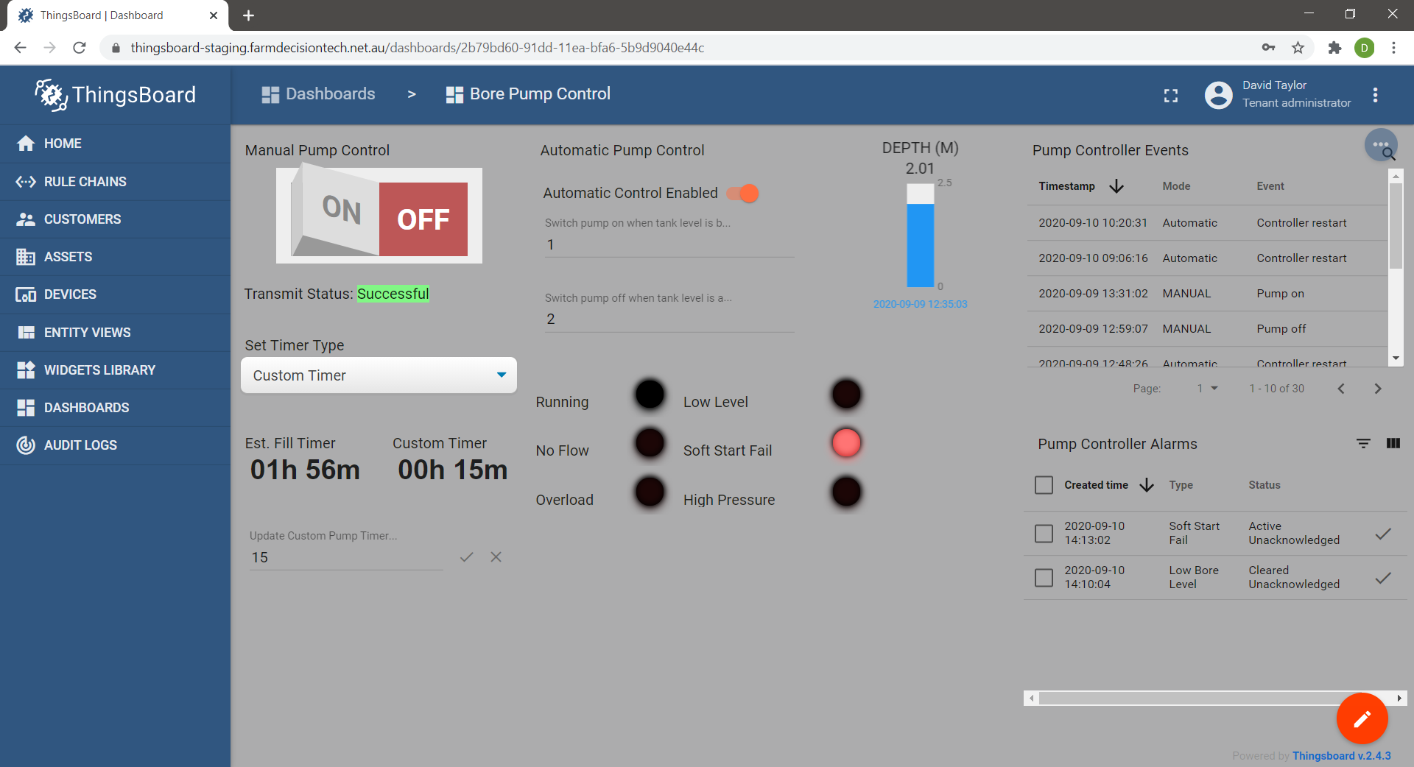

14:14:00.050 -> Sending status due to state change.

14:14:00.050 -> LoRaWAN will encode and send this message: {'pumpRunning':0,'boreLowLevel':0,'softStartFail':0,'pumpOverload':0,'controllerRestart':0,'highPressure':0,'noFlow':0}

14:14:00.050 -> Sending status byte: 00

14:14:02.395 -> EV_TXCOMPLETE (includes waiting for RX windows)

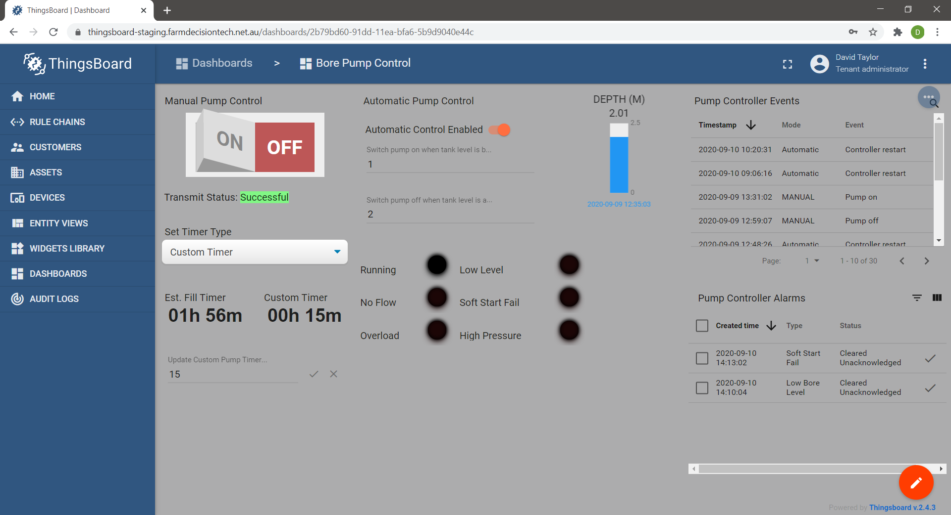

Steps 5 & 6 no flow

14:17:13.969 -> Sending status due to state change.

14:17:13.969 -> LoRaWAN will encode and send this message: {'pumpRunning':0,'boreLowLevel':0,'softStartFail':0,'pumpOverload':0,'controllerRestart':0,'highPressure':0,'noFlow':1}

14:17:13.969 -> Sending status byte: 40

14:17:16.328 -> EV_TXCOMPLETE (includes waiting for RX windows)

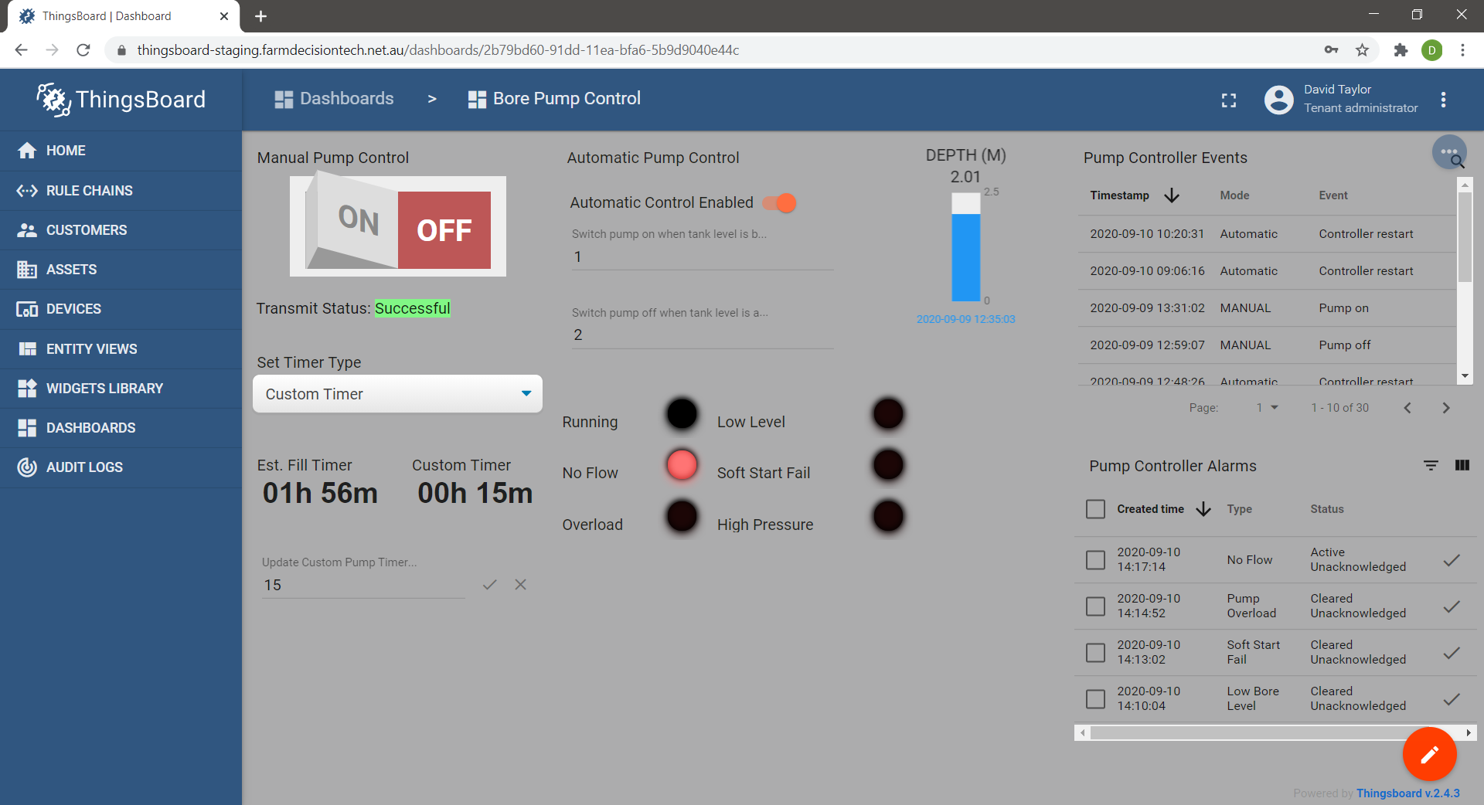

14:17:52.655 -> Sending status due to state change.

14:17:52.655 -> LoRaWAN will encode and send this message: {'pumpRunning':0,'boreLowLevel':0,'softStartFail':0,'pumpOverload':0,'controllerRestart':0,'highPressure':0,'noFlow':0}

14:17:52.655 -> Sending status byte: 00

14:17:52.903 -> Request scheduled status message to be sent.

14:17:52.903 -> Not ready to send.

14:17:55.005 -> EV_TXCOMPLETE (includes waiting for RX windows)

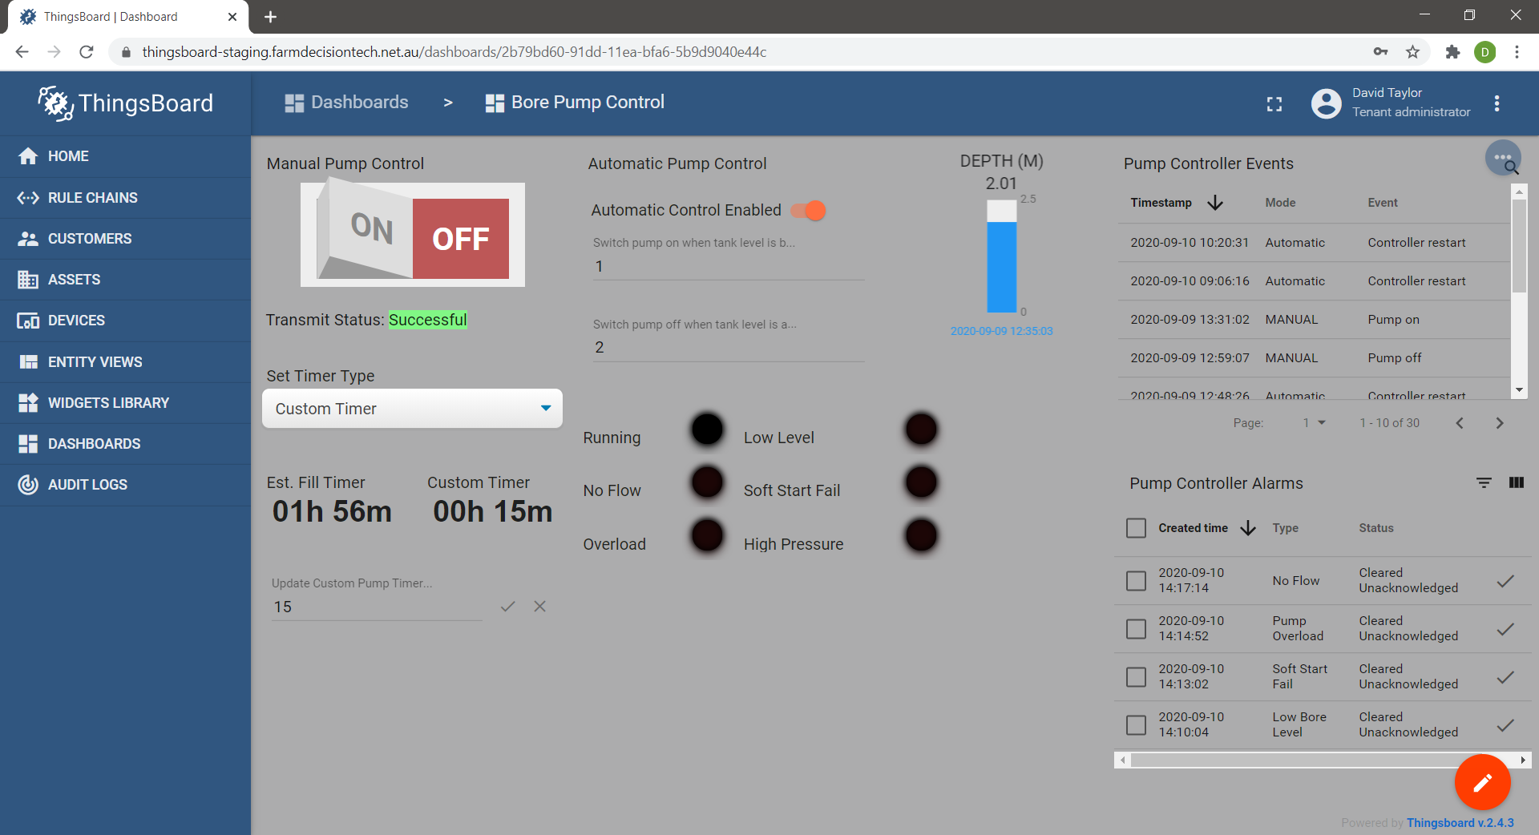

Steps 7 & 8 pump overload

14:14:51.380 -> Sending status due to state change.

14:14:51.380 -> LoRaWAN will encode and send this message: {'pumpRunning':0,'boreLowLevel':0,'softStartFail':0,'pumpOverload':1,'controllerRestart':0,'highPressure':0,'noFlow':0}

14:14:51.380 -> Sending status byte: 08

14:14:53.716 -> EV_TXCOMPLETE (includes waiting for RX windows)

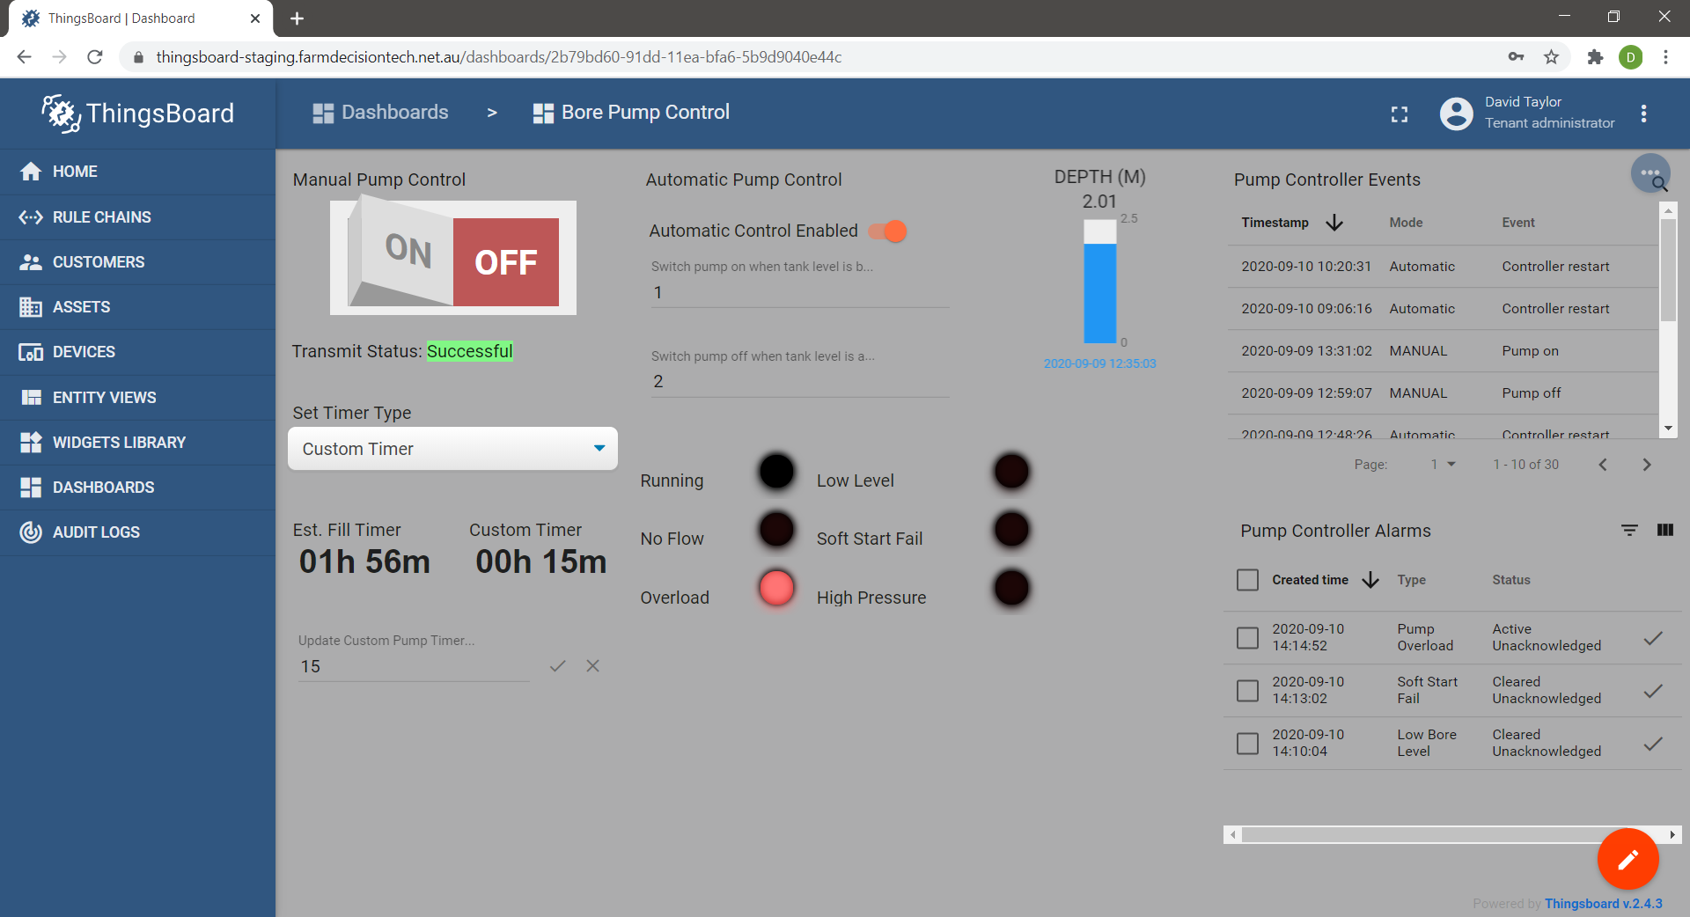

14:16:04.906 -> Sending status due to state change.

14:16:04.906 -> LoRaWAN will encode and send this message: {'pumpRunning':0,'boreLowLevel':0,'softStartFail':0,'pumpOverload':0,'controllerRestart':0,'highPressure':0,'noFlow':0}

14:16:04.906 -> Sending status byte: 00

14:16:06.488 -> EV_TXCOMPLETE (includes waiting for RX windows)

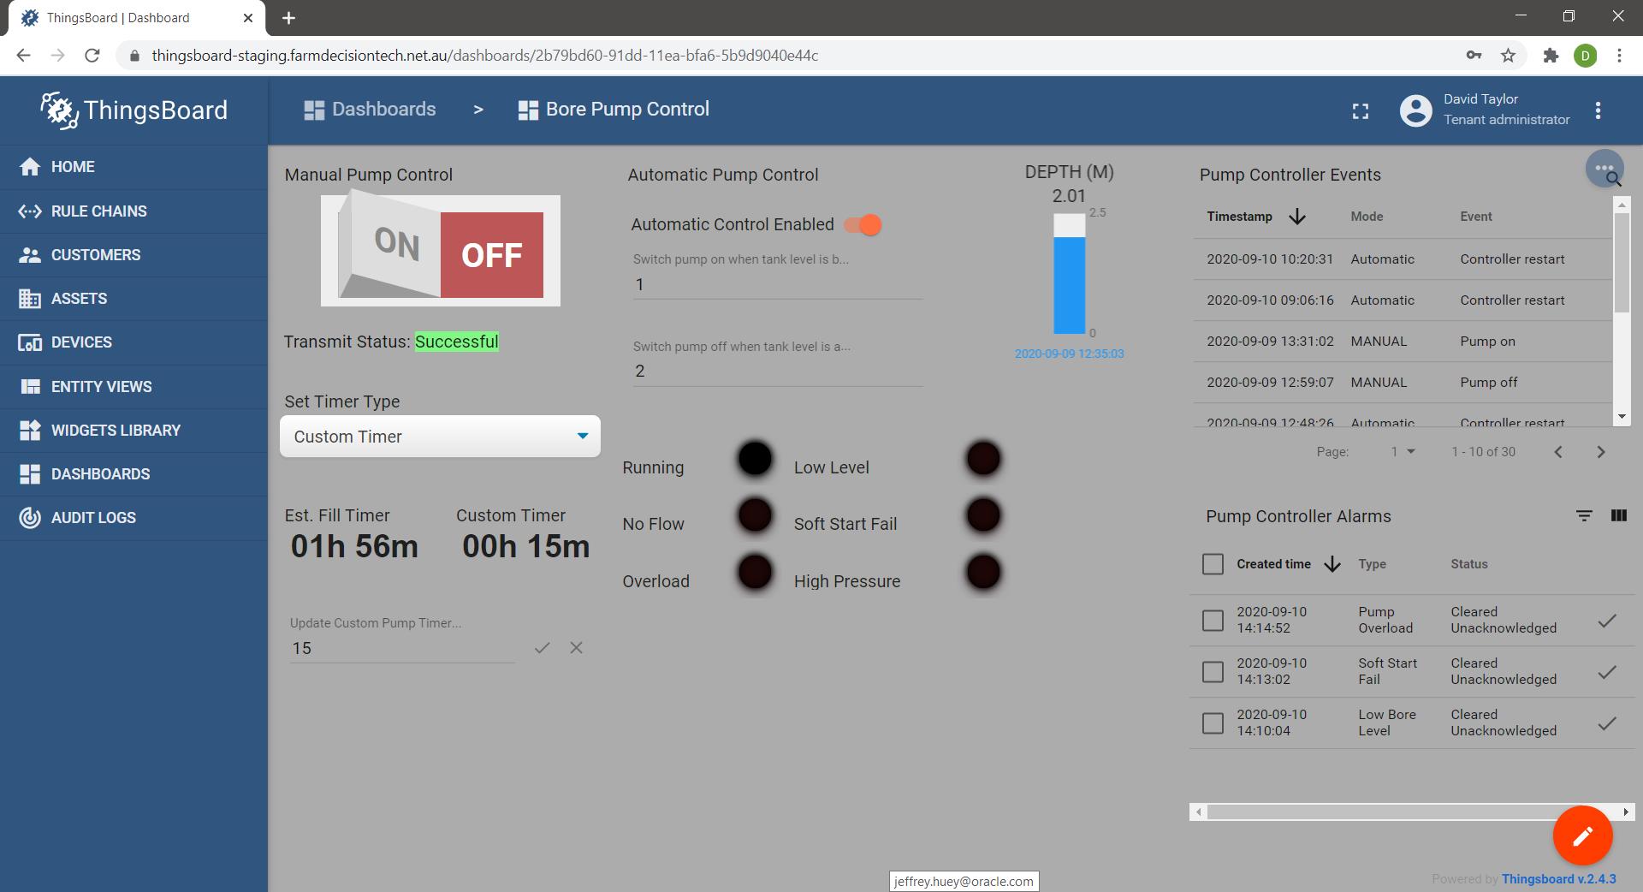

Steps 9 & 10 high pressure

14:19:08.470 -> Sending status due to state change.

14:19:08.470 -> LoRaWAN will encode and send this message: {'pumpRunning':0,'boreLowLevel':0,'softStartFail':0,'pumpOverload':0,'controllerRestart':0,'highPressure':1,'noFlow':0}

14:19:08.470 -> Sending status byte: 20

14:19:10.791 -> EV_TXCOMPLETE (includes waiting for RX windows)

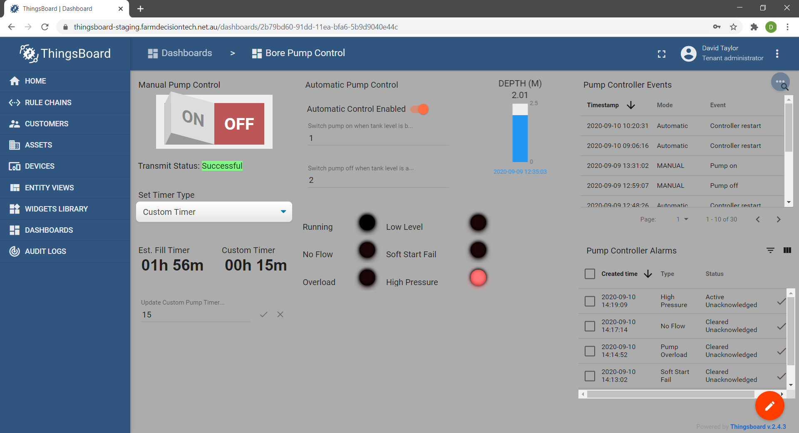

14:19:45.883 -> Sending status due to state change.

14:19:45.883 -> LoRaWAN will encode and send this message: {'pumpRunning':0,'boreLowLevel':0,'softStartFail':0,'pumpOverload':0,'controllerRestart':0,'highPressure':0,'noFlow':0}

14:19:45.883 -> Sending status byte: 00

14:19:48.251 -> EV_TXCOMPLETE (includes waiting for RX windows)

